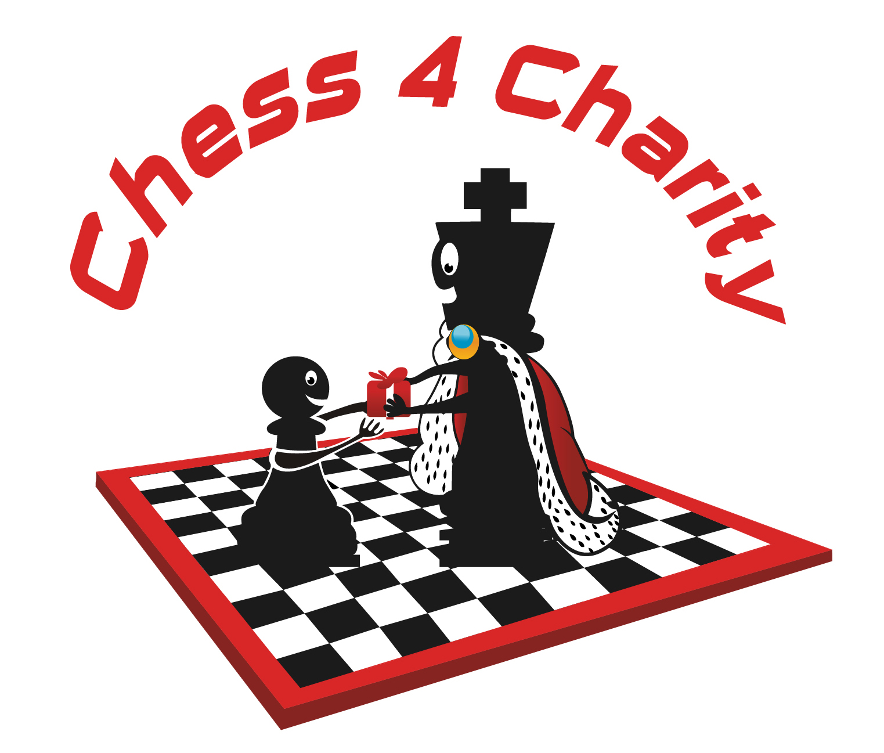
www.Chess4Charity.org

5th Semi-Annual
Charity Chess Tournament
October 15, 2017
BASIS Independent McLean (School), 8000 Jones Branch Drive, McLean, VA 22102
Main tournament from Noon - 5pm
Full schedule (come for the parts you can):
- 10:30-11:30am lecture by US Women’s Chess Champ Sabina Foisor
- 11:00-11:45 registration & check-in
- Noon - 5pm (approx.) main tournament (4 rounds); (silent auction; raffle)
- 5pm (approx.) simul with Praveen Balakrishnan (USCF rating 2501)
All ages (preschool to adult) & all skill levels (beginner to master) welcome
$50 early bird (sign up online before Oct 12); $65 after (all goes to charity)
Tournament Registration Fee includes the lecture, 2 slices of pizza, drink, raffle ticket
If you come in just for the lecture or just for the simul, we may ask for a modest donation
Sections: Open, U1000, and Unrated (beginner); SS4 G/25, d3 (Quick Rated)

Sign Up, Donate or learn more at: www.Chess4Charity.org
Chess 4 Charity is a 501(c)(3) created by kids | 100% of profits go to the Childhood Brain Tumor Foundation | call 703-403-5347 w questions

